Project
Prevent User Deletion if Assigned to Incident
Team ID: LTVIP2026TMIDS26598
Team Members: 04
Team Leader: Pachigolla Devi Likitha
Team Member: Koppaka Gnanendra Chowdary
Team Member: Kurma Jasta Naga Jyoshna
Team Member: K.Akash Babu
Problem Statement:
This project develops a server-side validation mechanism in ServiceNow to prevent accidental deletion of users who are assigned to active incidents. In IT Service Management systems, deleting a user record linked to incidents can cause workflow disruption, data inconsistency, and accountability loss.The solution implements a Before Delete Business Rule on the sys_user table, which checks the incident table using GlideRecord. If related incidents exist, deletion is blocked with an appropriate error message.This project enhances data integrity, workflow continuity, and system reliability within ServiceNow-based IT environments.
Objective:
The main objective of this project is to develop a centralized Incident Management System using ServiceNow that enables users to report incidents digitally and allows support teams to track, assign, prioritize, and resolve issues efficiently.
Skills:
- ServiceNow Platform Knowledge
- ITIL Concepts (Incident Management)
- JavaScript (Client Scripts & Business Rules)
- Database Concepts
- Workflow Automation
- Problem-Solving
- Analytical Thinking
- Team Collaboration
- Project Documentation

TASK INITIATION
- Module 1: User Creation



Step 1: Click on My instance

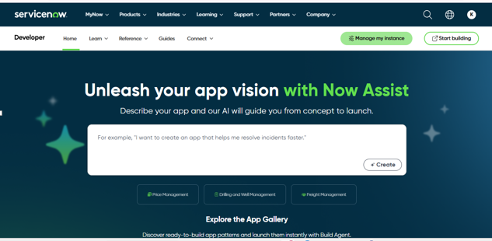

Step 2: Click on Instance url

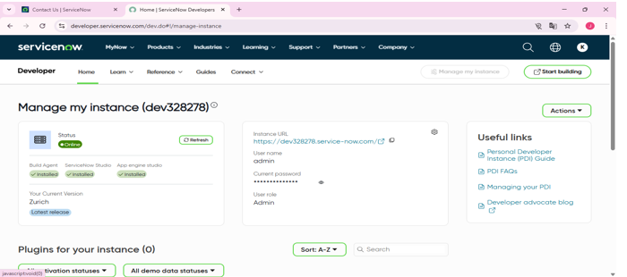

Step 3: Click on All>>Users (System Security)

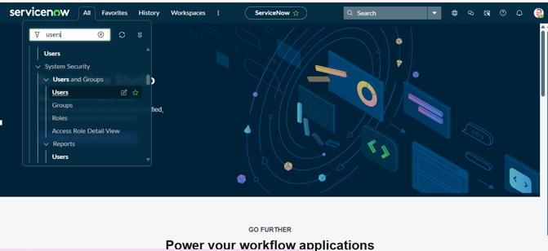

Step 4:click on New

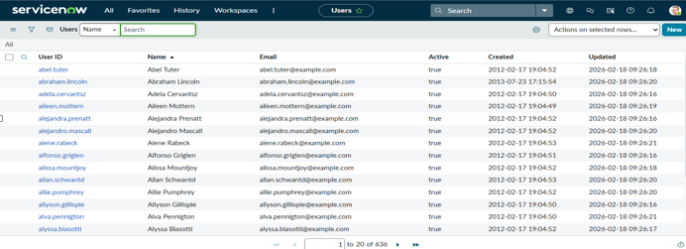

Step 5: Create Two users
Enter the Details >> Click on Submit.

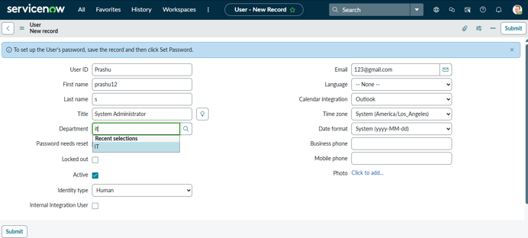
- Module 2: Assign incident to user
Step 1: Navigate to the incident
All>>incident
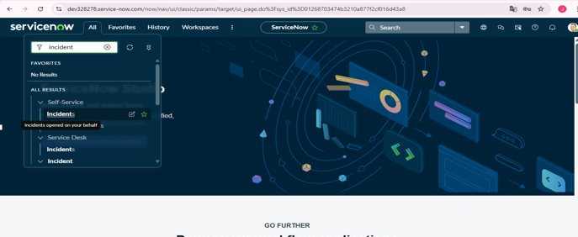

Step 2: Click On Create New incident

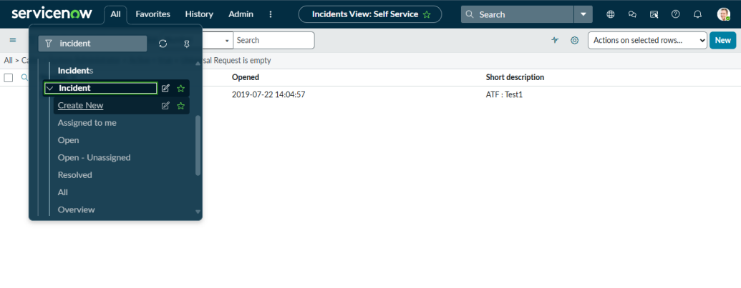

Step 3: Enter the Details: caller,state,assigned to >> Click on submit

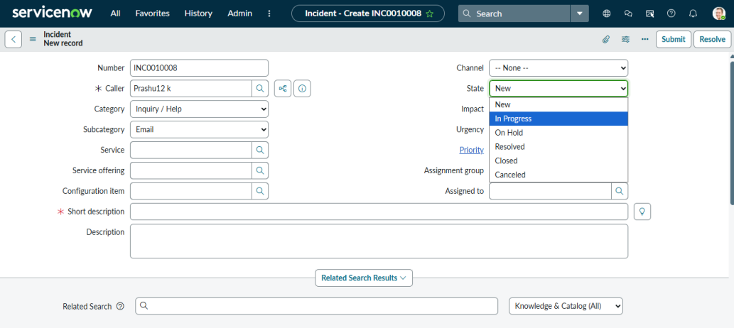

- Module 3: Business Rule Creation
Step 1:Go to System Definition>>Business Rule
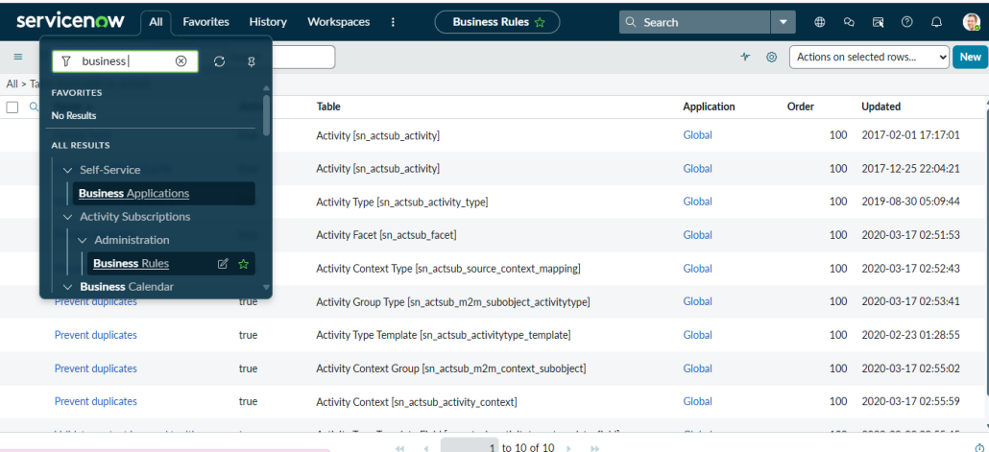

Step 2: Click on New

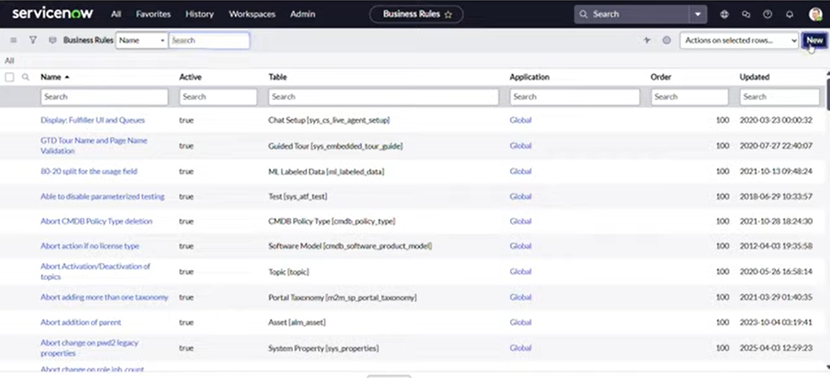

Step 3: Creting business rule
Enter details>>Name:Prevent User Deletion if assigned an incident,
Table:Select sys_user,Active:checked

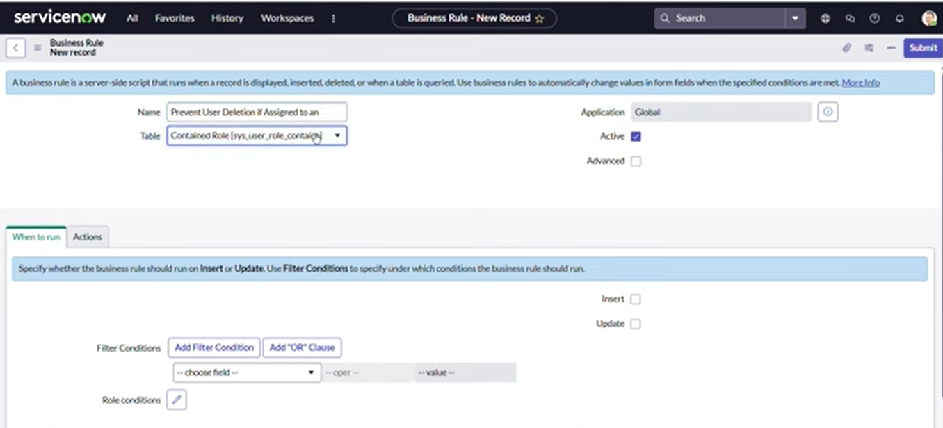

Step 7: Advanced:checked>>When:Before>>Delete checked
Code script:
(function executeRule(current, previous /null when async/) {

var incGr = new GlideRecord('incident');

incGr.addQuery('assigned_to', current.sys_id);

incGr.setLimit(1); // Just need to check existence

// incGr.addQuery('active', true); we can use the above or this line of code to check where the user is assigned with any incident

incGr.query();

if (incGr.next()) {

gs.addErrorMessage('This user cannot be deleted because they are assigned to one or more incidents.');

current.setAbortAction(true);

}

// Add your code here

})(current, previous);
>>Click on submit

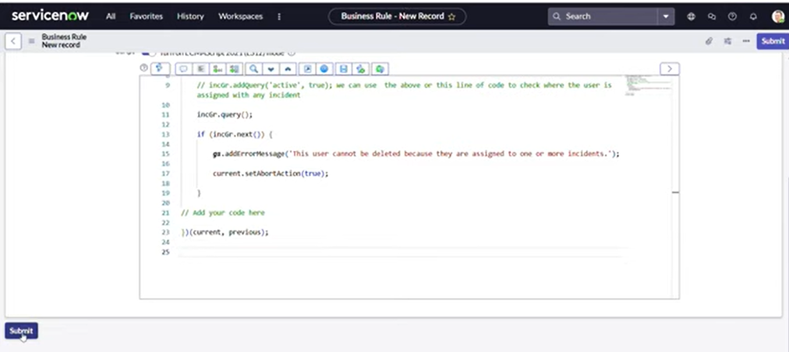

Module 4: Test deletion
Attemp to delete assignment user
Step 1:Go to user record>>Try to delete

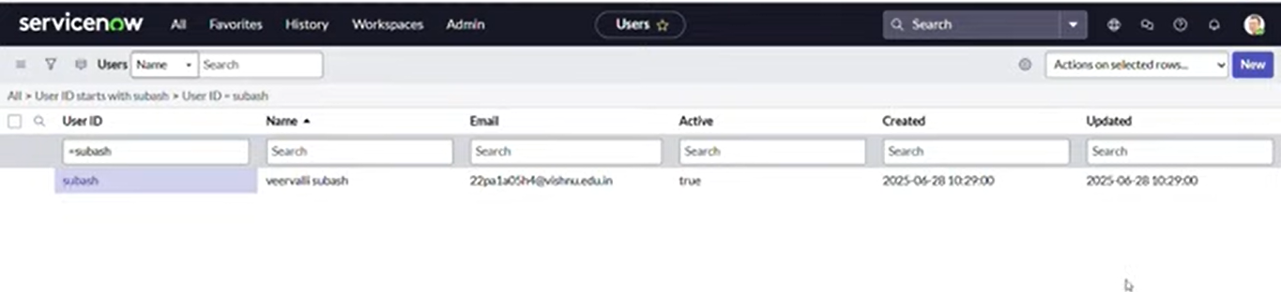

Step 2: Click on Delete

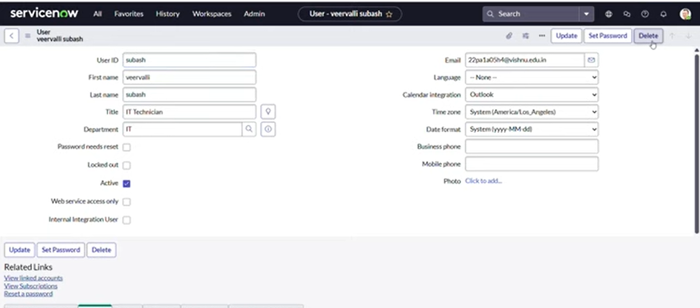

Step 2: Verify the delete is blocked with an error message

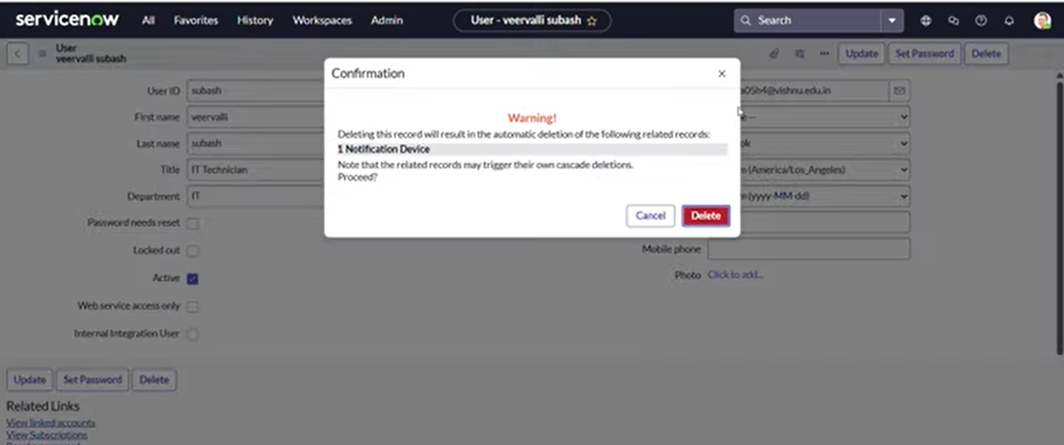

Module 5: Test with unassigned user
Step 1: Attempt to delete unassigned user.

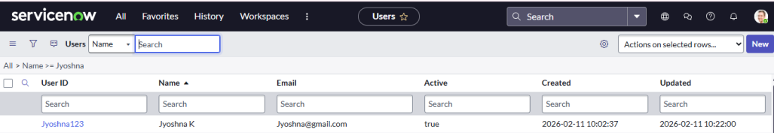

Step 2:Click on delete >>Delete shouls Succeed.

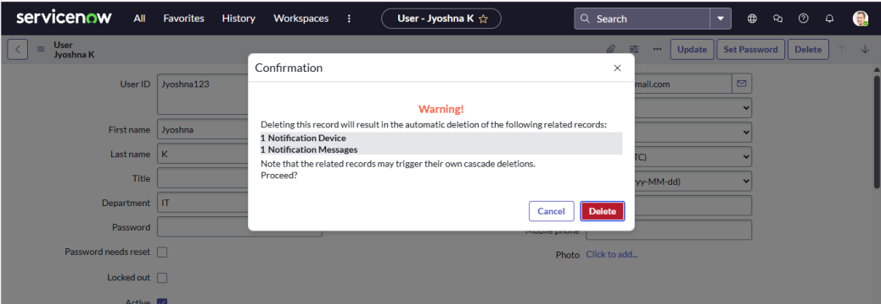

Conclusion:
The project “Prevent User Deletion if Assigned to Incident” successfully demonstrates how ServiceNow can be used to enforce data integrity and prevent critical system errors. In many organizations, deleting a user who is already assigned to active or historical incidents can lead to data inconsistencies, reporting issues, and loss of accountability.Through the implementation of a Before Delete Business Rule and server-side validation using GlideRecord, this project ensures that users linked to incidents cannot be deleted accidentally. The system displays a proper error message and restricts the action, thereby maintaining referential integrity within the Incident Management module.This solution enhances system reliability, improves administrative control, and protects organizational data from unintended modifications. Overall, the project highlights the importance of implementing validation mechanisms in IT Service Management platforms like ServiceNow to ensure secure and efficient operations.

